TILMA PARISH WEBSITE ANNOUNCEMENT

Learn how to create announcements to your TILMA parish website.

Upload image: 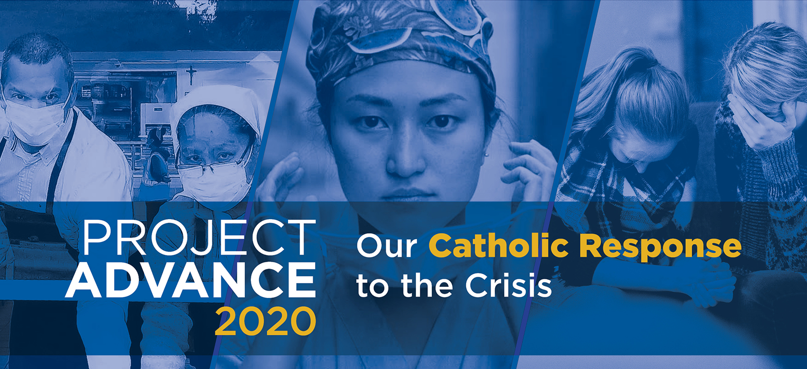

Announcement title: Project Advance 2020: Our Catholic Response to the Crisis
Announcement teaser: Click here to learn more about this year’s appeal.
Start Datetime: Parish decision
End Datetime: Dec 31, 2020 or parish decision
Link URL: www.projectadvance.ca

